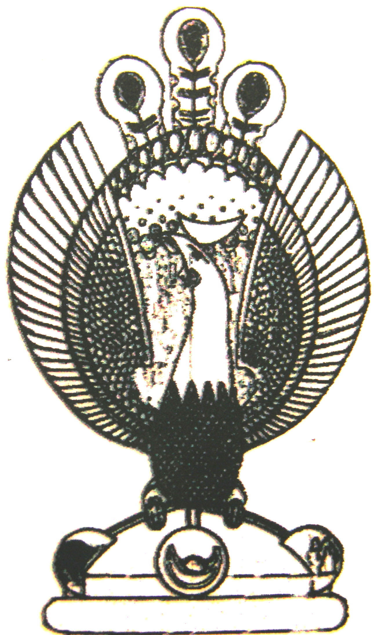

THE HERITAGE

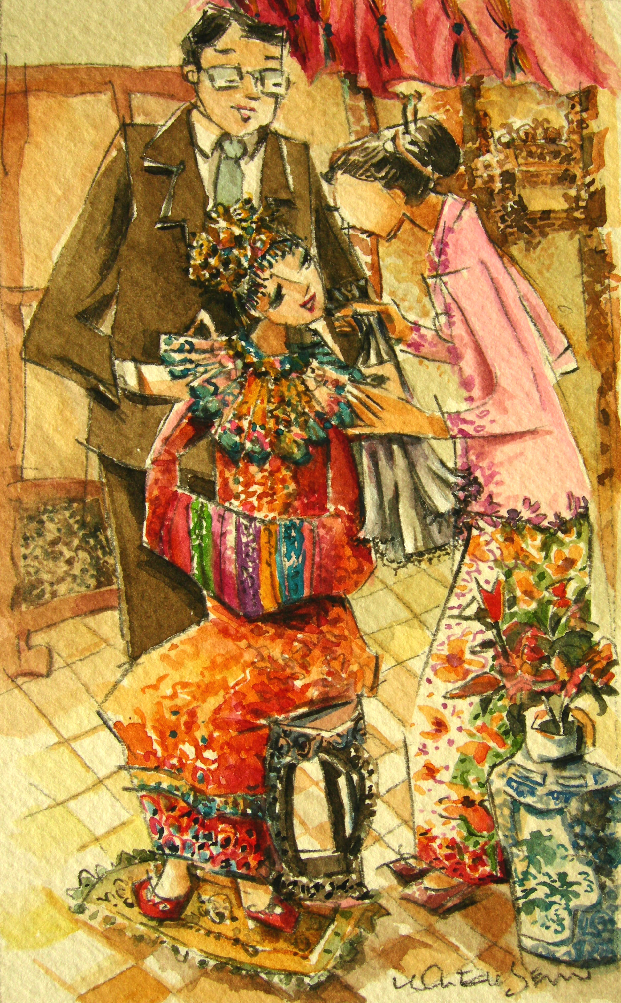
The Veil
Within the bridal chamber, the Sang Kheh Umm works on the bride. The bride’s parents cover her head with a black net-veil.
This symbolises her sadness at leaving behind her parents and childhood, and her nervousness
at becoming an adult.

